Case 6-AFR-Mali-Bandiagara-Nyerum and Nommo Dogon Water Spirits, ca 1700 CE

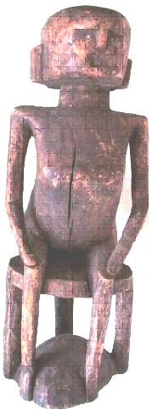

Fig. 1.

Case no.: 6

Accession Number:

Formal Label: Mali-Bandiagara-Nyerum and Nommo Dogon Water Spirits, ca 1700 CE

**Display Description:**

Among the Dogon of Mali, water is precious. During the Little Ice Age (1250-1800 CE) that reached its nadir ca 1450 CE, the Dogon people developed two ways of dealing with water: the social protection of potable water and its underlying cosmological basis for the Dogoan culture. These two conerns are represented respectively by Nyerum and Nommo.

Nyerum is a female, mythical, primordial, spirit in charge of the social supervision of water holes. Nyerum’s visage is portrayed in carved wooden figures as stern, inscrutable, and implacable. In this example she is represented as having an inscrutable stare, enhanced by small eyes fashioned from tiny metal plugs. In one of the stories about Nyerum, an elder says, 'If you stay three days without drinking you will die... . For Nommo and Nyerum we make offerings to ask them to give water... . Last year, the well in our village ate our child, so we made sacri­fices for all the things that were inside the well' (Boujou 2003).

Nommo is male the cosmological framework upon which Nyerum’s social control of water is predicated. Nommo is a cosmological figure carved from two circular disks of solid wood connected by bent “legs”. The upper disk, which is Nyerum’s seat, represents the sky, and the lower disk, represents water. Sky and water are connected by supporting bent posts metaphorically symbolizing Earth. These posts although uncarved are really the aniconic legs of Nommo. Twogether the upper and lower disks connected by the bent posts represent Nommo the cosmological stool that Nyerum is sitting on. On some stools the bent posts are actually carved male figures. *Nyerum* claims her authority over her male counterpart as protectress of the community’s access to potable water by having him support her. In Dogon society stools are considered to be objects of prestige that define social status. This figure of *Nyerum* and Nommo would have been placed in a shrine near a water source to whom prayers would have been made to insure the well-being of the community.

**LC Classification:** DT551.42

Date or Time Horizon: 19th c

Geographical Area: site of Djenné-Djeno, Mali, on the flood plain of the Bani River,3 km (1.9 mi) s of modern town.

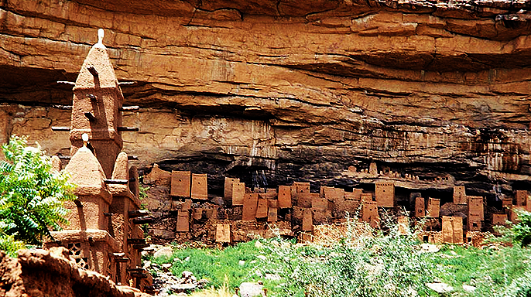

Fig. 2. Remnant dwellings of the ancient Tellem people in the background along the Bandiagara Escarpment, Mali, with a mud mosque of the modern-day Dogon village at the left, foreground, after <http://www.apsaidal.com/wp-content/uploads/2017/03/Tellem_Dwelling_Bandiagara_Escarpment_Mali.jpg>

**Map:**

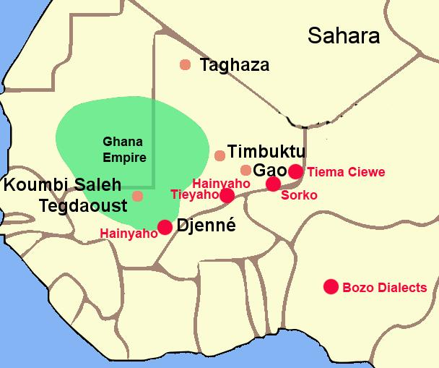

Fig. 3. The Ghana Empire 1000-1400 CE showing the ethnolinguistic groups along the Niger River. After <https://i.pinimg.com/564x/c6/a7/9b/c6a79b7443105f363ff965ebf420b7fd.jpg>

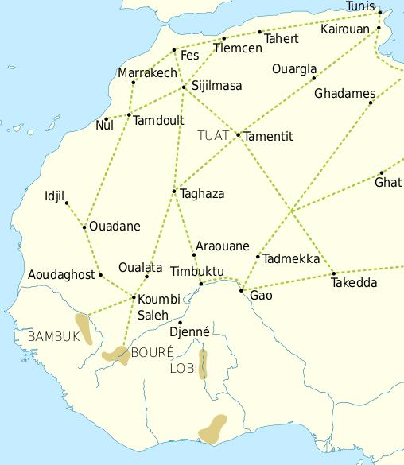

Fig. 4. Trade routes of the Western Sahara c. 1000-1500. Goldfields are indicated by light brown shading. After https://i.pinimg.com/564x/69/15/ce/6915ce6f4fd34025787fe59bd44f9eae.jpg

This trade resulted in an increasing surplus that helped expand urban centers such as Gao, Timbuktu and Djenné.

**GPS coordinates:** Djenné-Djeno, Mali: [13°53′26″N 4°32′25″W](https://tools.wmflabs.org/geohack/geohack.php?pagename=Djenné-Djenno&params=13_53_26_N_4_32_25_W_region:ML_type:landmark_source:dewiki)

Cultural Affiliation: Doogon

Medium: wood and metal

Dimensions:

Weight:

Condition: original

Provenance: purchased in a Bandiagara village in Mali in 1998 from local people who worship Nyerum and Nommo.

**Discussion:**

One elder from Mali explained that "Where rites have been forgotten, the water is scarce and therefore there is no life" (Boujou 2003). *Nyerum's* role is precisely to insure that the rites will be performed according to tradition and on schedule, hence her harsh demeanor. *Nyerum's role is to* insure that *Nommo* will leave the sky and descend to earth on rainbow's path. On earth he becomes a water spirit and makes the water "strong" and abundant. There are still some Dogon communities that claim *Nommo* as their ancestor, and call him *Binu*. The “bent legs” of Nommo are icons of water descending from the Sky disk, and in this sense they are not aniconic.

This tradition comes from the primeval Dogon myth of the world before the appearance of death. As elders were becoming too old, they would change themselves into a large water being, a python or a crocodile, and dwell in ponds and rivers, beginning a new life as a water spirit called *Nommo*, helping maintain the source of water for their descendants. These water spirits (*Nommo*) were, in fact, considered to be the ancestors of the autochthonous people still living in the area and were called "Binu" as a personal, familial nick-name, because they were, in fact, part of their family.

**References:**

Bouju, Jacky. 2003. "The spirit of Water: In the Dogon World," *Leonardo* (MIT Press), 36, No. 4:279-280.



Claerhout, François. 2015*. Dogon, comment ce monde vint au monde: cosmogonie des Dogons du Mali.* Bordeaux : Elytis: Diffusion Harmonia Mundi.

Griaule, Marcel. 1948. *Dieu de l’eau: entretiens avec Ogotemmeli*. Paris: Fayard, 1948.

Metropolitan Museum of Art. *Art of Oceania, Africa, and the Americas from the Museum of Primitive Art*. New York: The Metropolitan Museum of Art, 1969, no. 236.

**Appendix:**

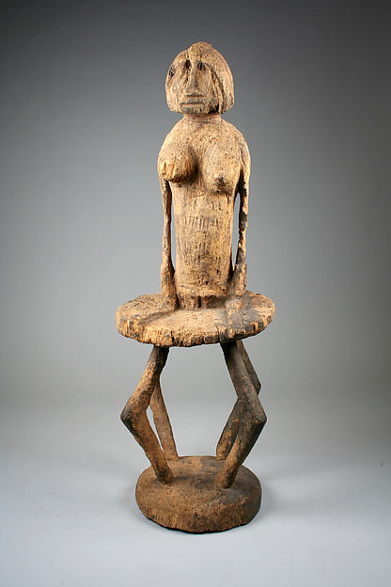

Fig. 5. Mali-Dogon peoples-Nyerum and Nomo-19th c. after https://metmuseum.org/art/collection/search/310939

Dimensions: H. 20 1/2 x W. 7 3/4 x D. 7 1/4 in. (52.1 x 19.7 x 18.5 cm)

Provenance: The Michael C. Rockefeller Memorial Collection, Gift of Nelson A. Rockefeller, 1964; [Henri Kamer, New York and Paris, until 1963]; Nelson A. Rockefeller, New York, on loan to The Museum of Primitive Art, 1963–1964; The Museum of Primitive Art, New York, 1964–1978. Then the Metropolitan Museum of Art, New York, Acc. No. 1978.412.478.